Hygiene Kits
for
Point In Time Count & Warming Center

Kit Contents
Toothpaste (travel size) Deodorant
Shampoo (travel size) Razors
Bar soap (hotel size) Granola Bars
Lotion (hotel size) Feminine hygiene products
Toilet Paper (1 roll) Chapstick
Travel size disinfecting wipes Hand sanitizer
Toothbrush Hand warmer

The above listed items can be placed in one gallon size Ziplock bag or placed any equivalent 1 gallon size container, as illustrated below.

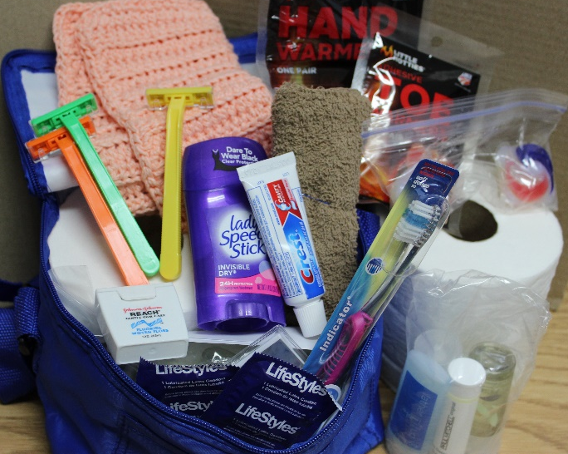

Drop off site is Serve Moses Lake

